XIT
Thursday and Friday ONLYand





IMPORTANT INFO.
- For your safety, please do not drop-off until 7:30 a.m.

- Parents choosing to park MUST walk their child to the building. Children cannot walk across the parking lot by themselves.

- Students are considered tardy if they are not at school by 8:00 a.m.
Morning Arrival


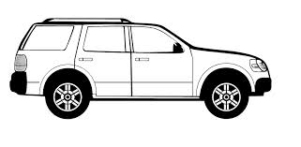
BUSES ONLY

Parent
PARKING
Teacher & Parent PARKING

ENTER
CARS
EXIT
CARS
GATE

Crosswalk

RIGHT LANE
Parking and Drop Off
LEFT LANE
Drop Off ONLY

CEDARCREST ROAD

